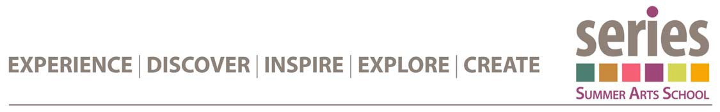
Pastel Essentials

Instructor: Susan Woolgar

Classroom Supplies provided by RDC:
Supply List for pastel course:
Board for mounting paper. 18x24,
tin foil,
painters tape,
latex gloves,
spray bottle,
apron,
4 inch soft brush,
small mohair or Velour roller(4 inch at least)
plastic or foam trays for mixing surface(I use old meat trays)
Gesso, black, yellow ochre, burnt sienna, ultramarine blue, hansa yellow, naphol or Bright red cheap acrylic paint.
1 pad canson xl watercolour pad 12x18,
1 set of 36 nupastel(or bigger)
one set of at least 36 soft pastels such as Rembrandt, Unison, Masters(check your Local art store)
- I will also have some homemade pastels for sale. If already have pastels bring them.
I bottle of rubbing alcohol,
container for water,
one bottle of Liquitex CLEAR gesso( different than regular gesso)
- reference will be available, but you are welcome and encouraged to bring your own.

